Q1.
Answer is C.

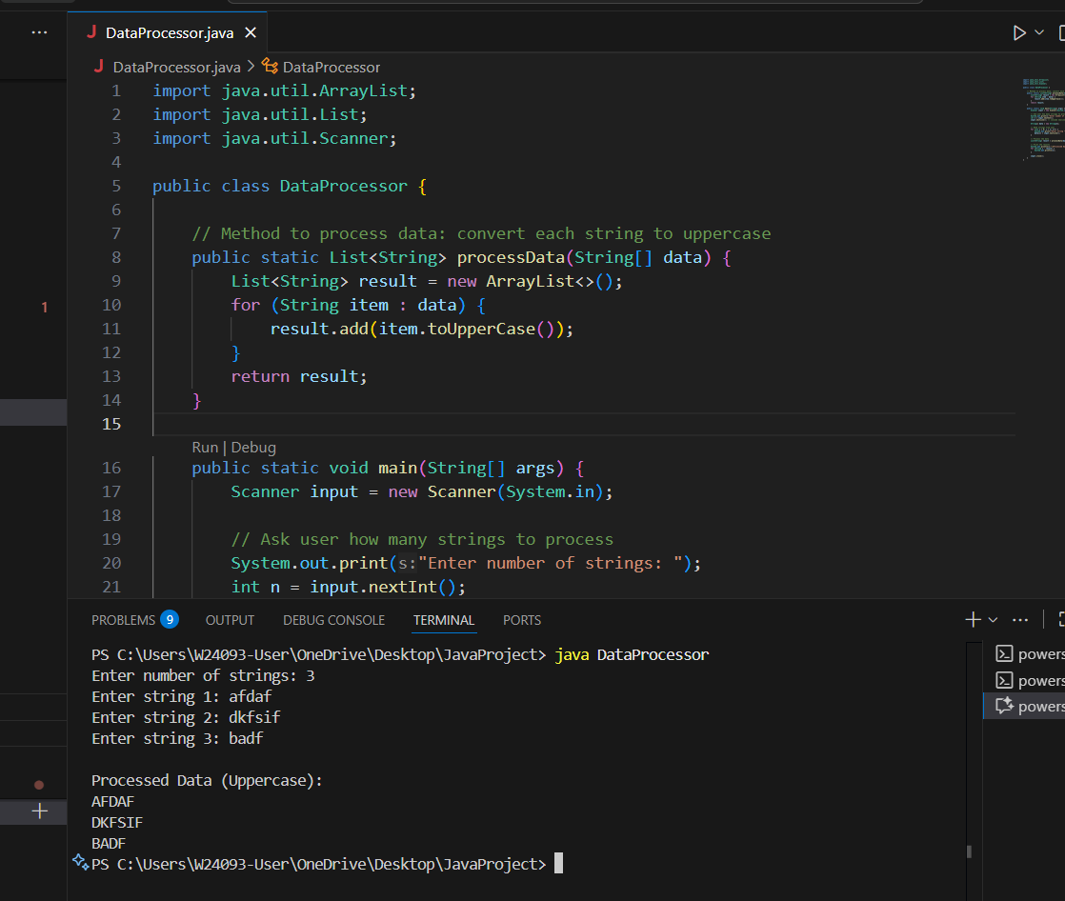

A: Changing the type of list does not solve the memory issue.

B: This can temporarily allow more data to fit in memory.But it is not scable.

C: Instead of holding all results in memory.And process, save/write, or stream small portions (batches) at a time.avoid OutOfMemoryError.

D: This is useful only if concatenating many strings repeatedly.

Q2.
Answer is B.

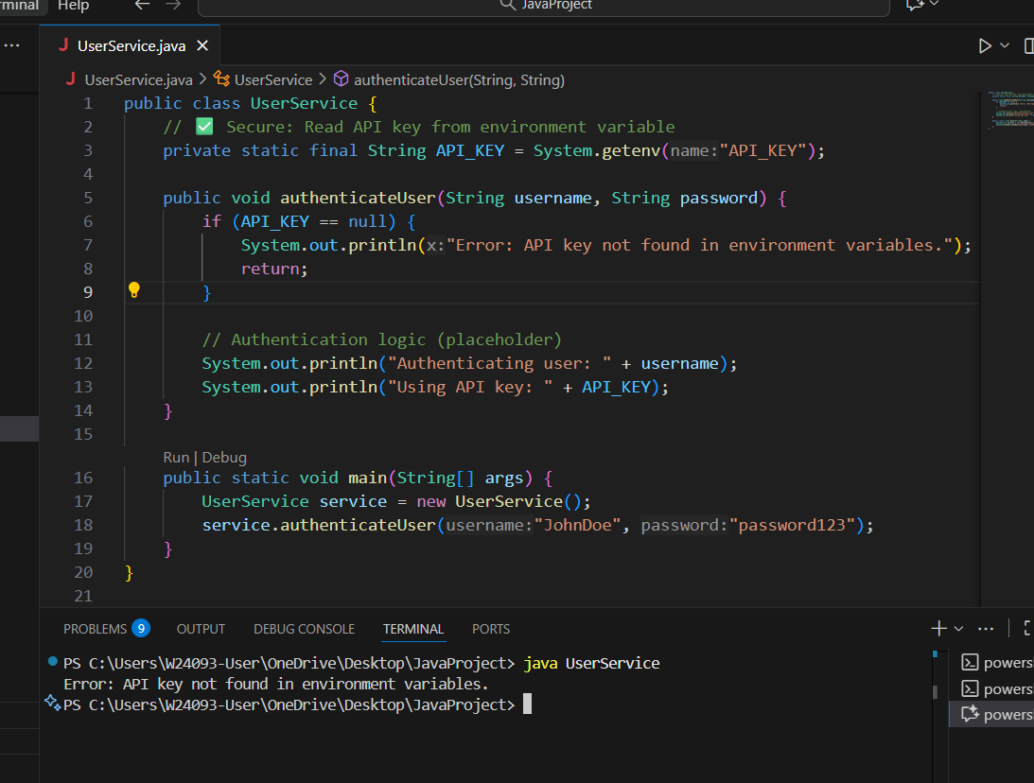

A: That means its value cannot be changed once assigned — this is not an issue.

B: Store the API key in an environment variable or a secure configuration file.

C: There’s no reason the authenticateUser method must be static.

D: Incorrect.

Q3.
Answer is B.

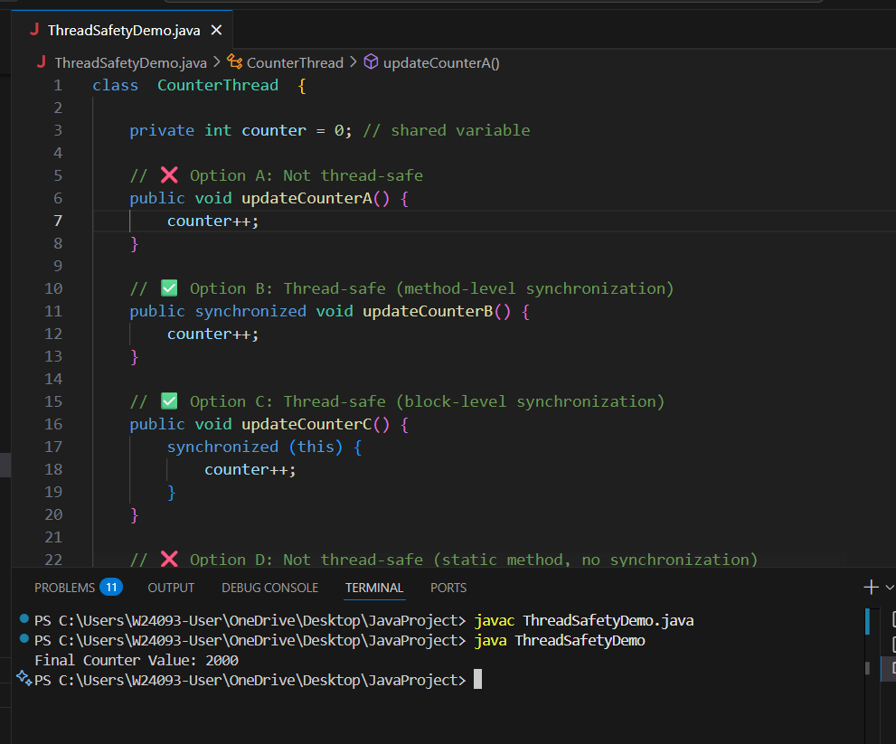

A: Not thread-safe.

B: Thread-safe.

C: Also thread-safe.

D: Not thread-safe.

Q4.
Answer is D.

A: Optional is meant for return types, not parameters.Not ideal here.

B: It doesn’t handle empty strings, so you still need to check isEmpty() inside.

C: Helps only for null, not for empty strings.

D: Use well-tested utility libraries like Apache Commons Lang to handle common string operations.

Q5.
Answer is B.

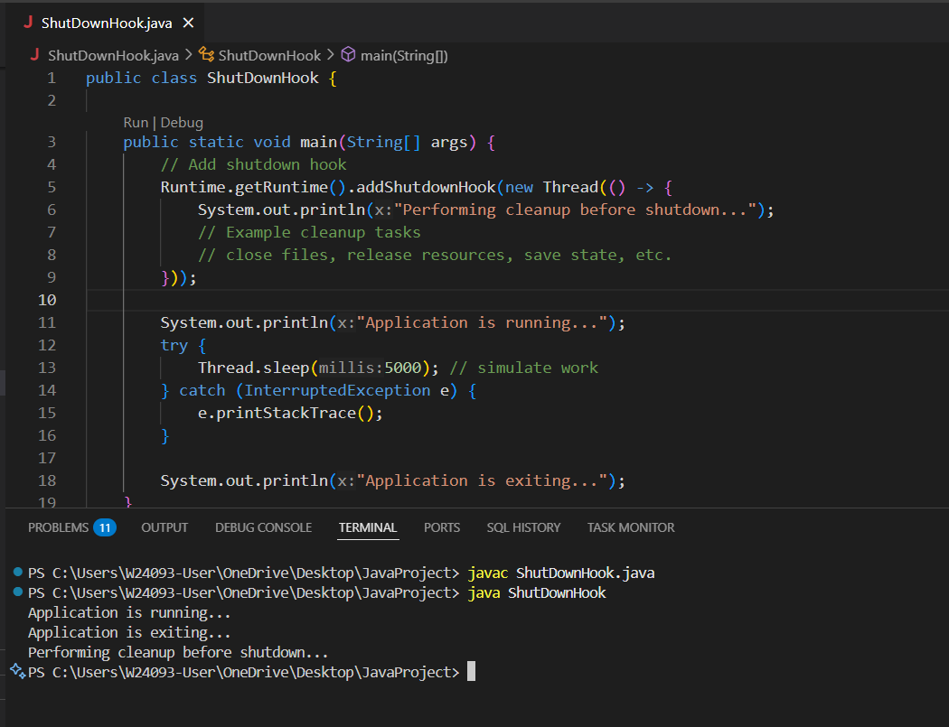

A: System.exit() stops JVM immediately.

B: Shutdown hook executes on normal exit & interrupts.

C: Finally runs only if JVM exits normally.

D: Only works for AutoCloseable resources.

Q6.
Answer is C.

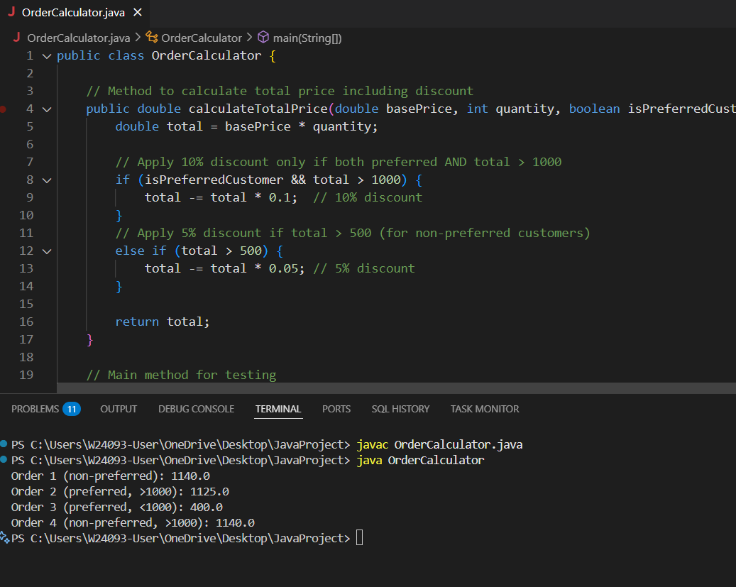

A: Correct tax calculation.

B: Correct total calculation.

C: Bug — return prevents rounding code from running.

D: Correct rounding line, but placed after return.

Q7.
Answer is D.

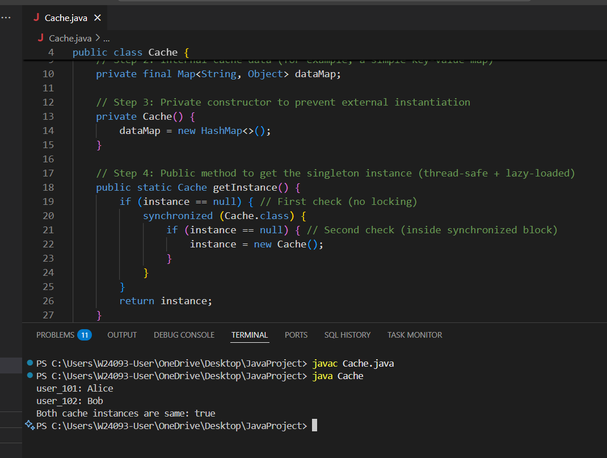

A: Fast but unsfe.

B: Fast.

C: Slow.

D: Fast and safe.

Q8.
Answer is C.

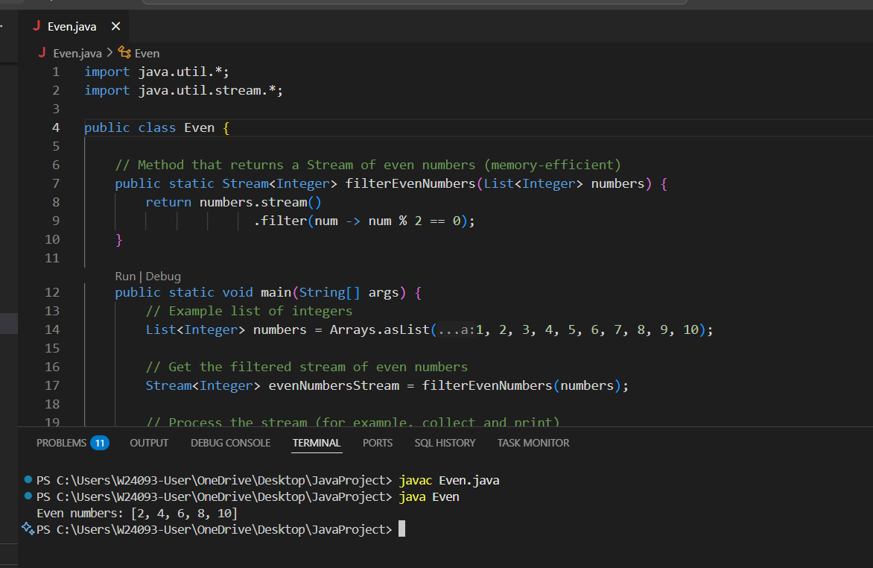

A: it increases memory usage due to thread overhead.

B: memory-heavy like the original.

C: Efficient for large data.

D: it still stores all results in memory.

